How well does IOWA layer segmentation agree with ground truth on OCTA-500 B-scans?
Part 1: boundary error, layer overlap and layer thickness
30 B-scans from 30 eyes (21 normal-looking, 9 diseased-looking). Segmentation: Iowa Reference Algorithms, OCTExplorer 5.0.0b, Default configuration. Data: OCTA-500, 3 mm scans.

1. Introduction
IOWA is free research software that finds the boundaries between the layers of the retina in an OCT scan [2-5]. OCTA-500 is a public dataset that comes with layer boundaries drawn for each scan [1]. We ask a simple question: how close are IOWA's boundaries to these drawn boundaries, and where does IOWA go wrong?

1.1 Terms used in this report
Term | Meaning
OCT, B-scan | OCT takes depth images of the retina. One B-scan is one such image: 304 columns across (3 mm) and 640 rows deep (2 mm). One eye has 304 B-scans.
Boundary | A line between two retinal layers, drawn as one depth value per column. We use six: ILM, IPL-INL, OPL-HFL, BMEIS, IB_RPE and OB_RPE (names as in the IOWA output).
Layer | The band between two neighbouring boundaries. The five layers are named by their two boundaries, for example IPL-INL->OPL-HFL. Total retina is ILM to OB_RPE.
Ground truth (GT) | The boundaries supplied with OCTA-500. They were first made by IOWA 3.8 and then corrected by hand (see section 4.1).
RMSE (um) | Root mean square error: the typical vertical distance between IOWA's boundary and the GT boundary, in micrometres. 0 is perfect. One image row is 3.125 um.
Dice | Overlap of a layer drawn by IOWA with the same layer in GT, from 0 (no overlap) to 1 (identical).
Thickness | Distance between two boundaries in um. Thickness bias is IOWA minus GT: above 0 means IOWA is thicker.
Normal-looking, diseased-looking | Our own grouping from looking at the B-scans (no diagnosis list exists for these eyes). Diseased-looking means visible cysts or swelling.
Default configuration | OCTExplorer's standard setting for most scans. The Cyst configuration is meant for scans with cysts and was not tested here.

1.2 Scope of this report
This report (Part 1) compares IOWA's layer boundaries with the ground truth on one B-scan per eye. It covers the boundary error, the layer overlap, the layer thickness, the three worst diseased-looking images and the normal-looking images at the foveal pit. The outline files, the topographic maps and the run time are reported separately in Part 2.

2. Methodology

2.1 Data and choice of images
OCTA-500 has images for eyes 10301 to 10400 in the part we hold. Eyes 10333 and 10388 are the same scan stored twice, so we used neither. We planned 30 eyes: one B-scan from each of 30 different eyes. Always included: 10306 and 10335 (both cystic).
- Normal-looking eyes: the B-scan at the foveal pit, found from the GT as the thinnest part of the retina near the centre of the scan.
- Diseased-looking eyes: the B-scan with the largest GT abnormality (the thickest cyst band, or the thickest retina for eyes with a raised dome). Only 9 eyes in this set show visible disease close to the centre, so the groups are not equal in size.
- The choice uses the GT only and never looks at the IOWA result.
Eye | Group | B-scan | How the B-scan was chosen | Scored
10302 | diseased | 160 | largest GT cyst-band thickness | yes
10306 | diseased | 124 | largest GT cyst-band thickness | yes
10310 | diseased | 149 | largest GT total retina thickness (raised dome) | yes
10317 | diseased | 212 | largest GT cyst-band thickness | yes
10325 | diseased | 133 | largest GT cyst-band thickness | yes
10335 | diseased | 138 | largest GT cyst-band thickness | yes
10367 | diseased | 147 | largest GT total retina thickness (raised dome) | yes
10373 | diseased | 194 | largest GT cyst-band thickness | yes
10380 | diseased | 119 | largest GT cyst-band thickness | yes
10304 | normal | 156 | foveal pit (min smoothed GT total thickness) | yes
10307 | normal | 157 | foveal pit (min smoothed GT total thickness) | yes
10314 | normal | 144 | foveal pit (min smoothed GT total thickness) | yes
10315 | normal | 152 | foveal pit (min smoothed GT total thickness) | yes
10320 | normal | 154 | foveal pit (min smoothed GT total thickness) | yes
10323 | normal | 163 | foveal pit (min smoothed GT total thickness) | yes
10330 | normal | 157 | foveal pit (min smoothed GT total thickness) | yes
10334 | normal | 153 | foveal pit (min smoothed GT total thickness) | yes
10340 | normal | 155 | foveal pit (min smoothed GT total thickness) | yes
10343 | normal | 162 | foveal pit (min smoothed GT total thickness) | yes
10356 | normal | 152 | foveal pit (min smoothed GT total thickness) | yes
10357 | normal | 158 | foveal pit (min smoothed GT total thickness) | yes
10363 | normal | 154 | foveal pit (min smoothed GT total thickness) | yes
10366 | normal | 160 | foveal pit (min smoothed GT total thickness) | yes
10372 | normal | 143 | foveal pit (min smoothed GT total thickness) | yes
10377 | normal | 152 | foveal pit (min smoothed GT total thickness) | yes
10383 | normal | 155 | foveal pit (min smoothed GT total thickness) | yes
10395 | normal | 154 | foveal pit (min smoothed GT total thickness) | yes
10396 | normal | 153 | foveal pit (min smoothed GT total thickness) | yes
10398 | normal | 148 | foveal pit (min smoothed GT total thickness) | yes
10399 | normal | 156 | foveal pit (min smoothed GT total thickness) | yes

2.2 Segmentation procedure
1. For each eye we made a 21-B-scan volume centred on the chosen B-scan (10 on each side). IOWA needs neighbouring B-scans to work in 3D, and 21 keeps each run short.
2. A person opened each volume in OCTExplorer 5.0.0b, picked Configuration-Default.json, and clicked through the two steps. No surface was edited or nudged.
3. Only the chosen B-scan (the centre one) was compared with GT. The other 20 are context.
4. The comparisons were made with the code listed in Appendix B (section 9). The resulting tables are in the repository folder tables/.

2.3 How we score
For each scored B-scan we compare IOWA's six boundaries with the six GT boundaries. The boundary error is the RMSE (um) defined in section 1.1; we give it for each boundary and for all six boundaries together. The layer overlap is the Dice value of each of the five layers and of the whole retina. Thickness is the distance between two boundaries in um; for each of the five layers and for the total retina we report the mean thickness in GT and in IOWA, the mean bias (IOWA minus GT) and the RMSE of the thickness. Each eye contributes one value per measure. Group results are the mean and the standard deviation (SD) across eyes, and the individual eyes are shown as dots in the figures.

2.4 Method checks
Two checks on the method:
- Gate: our scoring code reproduces the earlier result for eye 10301 (B-scans 120-180) of 3.84 um RMSE from the existing IOWA file (we get 3.8439 um).
- Is 21 scans enough? On one eye (10301, B-scan 150) we ran 21 scans and compared with the earlier 61-scan run. Overall error 4.20 um with 61 scans and 4.19 um with 21 scans. This is one eye with a normal retina, so it does not prove 21 scans are enough for cystic eyes.

3. Results

3.1 Error of each boundary
Each bar is the mean over eyes of the RMSE of one boundary. The thin bars show the standard deviation across eyes (the lower end is cut at 0). The black dots are individual eyes.
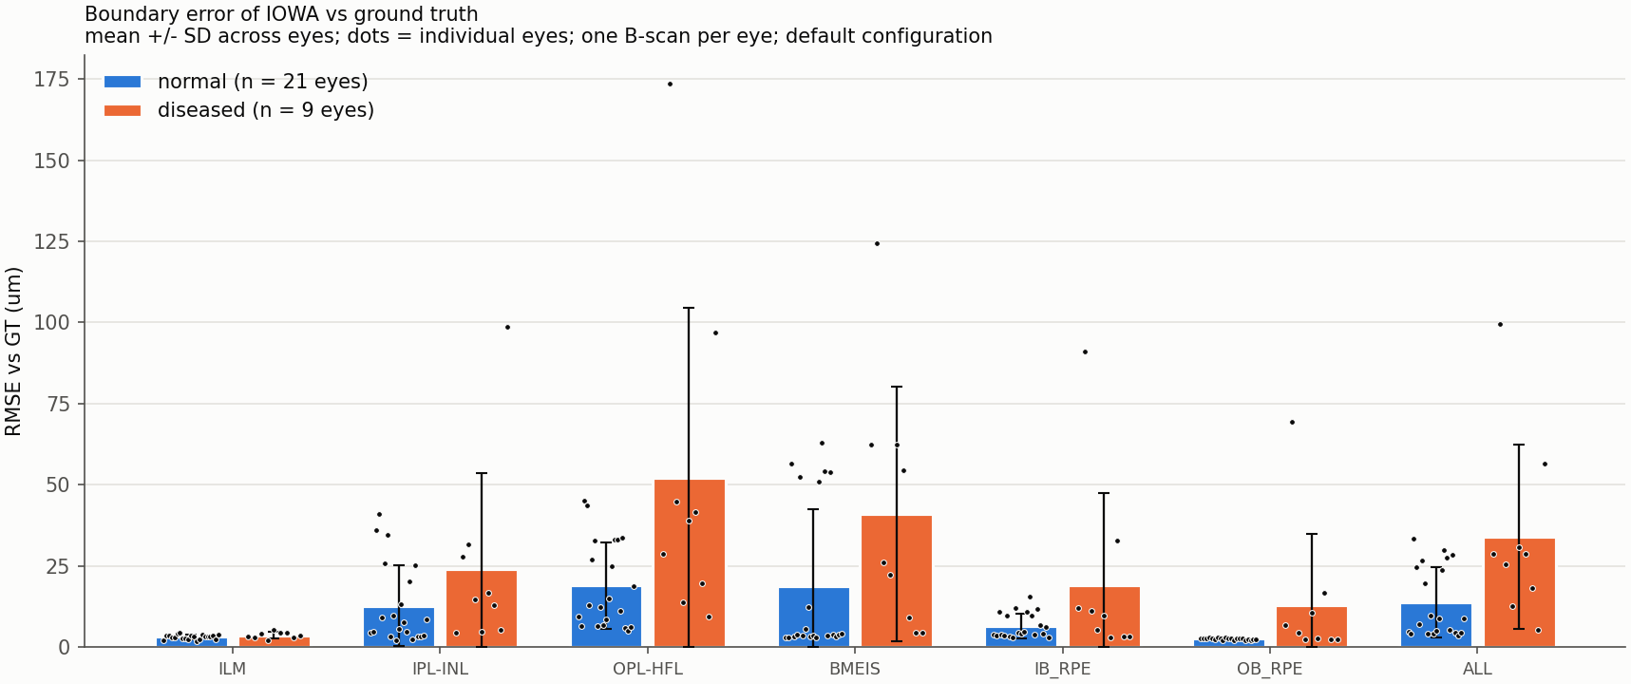
Figure 1. Boundary error of IOWA against GT, one B-scan per eye, Default configuration.
Boundary | Normal-looking (n = 21), um | Diseased-looking (n = 9), um
ILM | 3.2 +/- 0.7 | 3.6 +/- 1.0
IPL-INL | 12.8 +/- 12.4 | 24.1 +/- 29.5
OPL-HFL | 18.9 +/- 13.3 | 52.0 +/- 52.5
BMEIS | 18.8 +/- 23.8 | 41.1 +/- 39.2
IB_RPE | 6.6 +/- 3.8 | 19.1 +/- 28.5
OB_RPE | 2.6 +/- 0.3 | 13.0 +/- 21.7
All six boundaries | 13.7 +/- 10.9 | 34.0 +/- 28.5

Values are mean +/- SD across eyes. The SD is often as large as the mean because a few eyes have very large errors; with this few eyes the difference between the groups should be read as a trend, not a proven difference.

3.2 Overlap of each layer
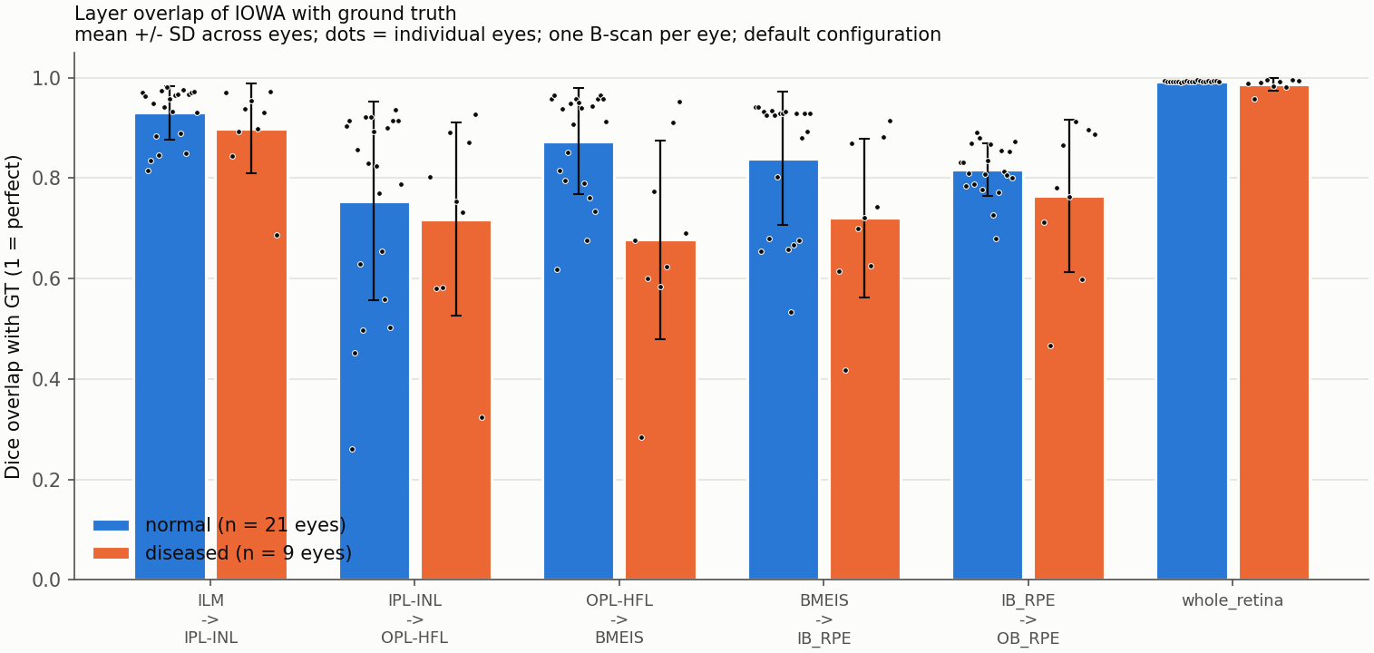
Figure 2. Dice overlap of each layer with GT. Higher is better.
Layer | Normal-looking (n = 21) | Diseased-looking (n = 9)
ILM->IPL-INL | 0.930 +/- 0.054 | 0.899 +/- 0.089
IPL-INL->OPL-HFL | 0.754 +/- 0.198 | 0.718 +/- 0.193
OPL-HFL->BMEIS | 0.874 +/- 0.106 | 0.677 +/- 0.197
BMEIS->IB_RPE | 0.839 +/- 0.132 | 0.721 +/- 0.157
IB_RPE->OB_RPE | 0.817 +/- 0.052 | 0.765 +/- 0.151
Whole retina | 0.993 +/- 0.001 | 0.987 +/- 0.012

The whole retina overlaps almost perfectly in both groups (0.993 and 0.987) because the top and bottom surfaces are easy to find. This number hides the errors inside the retina, so the per-layer values matter more.

3.3 Layer thickness
Thickness is the distance between two boundaries. The table gives the average thickness in GT and in IOWA, the mean bias (IOWA minus GT) and the RMSE of the thickness.
Normal-looking eyes (n = 21)
Layer | GT mean (um) | IOWA mean (um) | Bias, IOWA - GT (um) | RMSE (um)
ILM->IPL-INL | 75.8 | 79.6 | +3.8 | 13.0 +/- 12.0
IPL-INL->OPL-HFL | 46.7 | 47.4 | +0.7 | 10.6 +/- 6.8
OPL-HFL->BMEIS | 103.7 | 92.3 | -11.4 | 19.6 +/- 14.5
BMEIS->IB_RPE | 46.0 | 52.5 | +6.4 | 16.0 +/- 19.7
IB_RPE->OB_RPE | 18.7 | 20.8 | +2.1 | 6.5 +/- 4.7
Total retina (ILM->OB_RPE) | 291.0 | 292.6 | +1.6 | 3.9 +/- 0.7

Diseased-looking eyes (n = 9)
Layer | GT mean (um) | IOWA mean (um) | Bias, IOWA - GT (um) | RMSE (um)
ILM->IPL-INL | 91.9 | 100.0 | +8.1 | 23.9 +/- 28.8
IPL-INL->OPL-HFL | 88.1 | 99.3 | +11.3 | 41.3 +/- 50.6
OPL-HFL->BMEIS | 124.1 | 79.6 | -44.5 | 56.1 +/- 57.8
BMEIS->IB_RPE | 50.0 | 69.2 | +19.2 | 32.8 +/- 22.3
IB_RPE->OB_RPE | 25.8 | 24.9 | -0.9 | 14.0 +/- 12.8
Total retina (ILM->OB_RPE) | 379.9 | 373.0 | -6.8 | 14.3 +/- 22.0

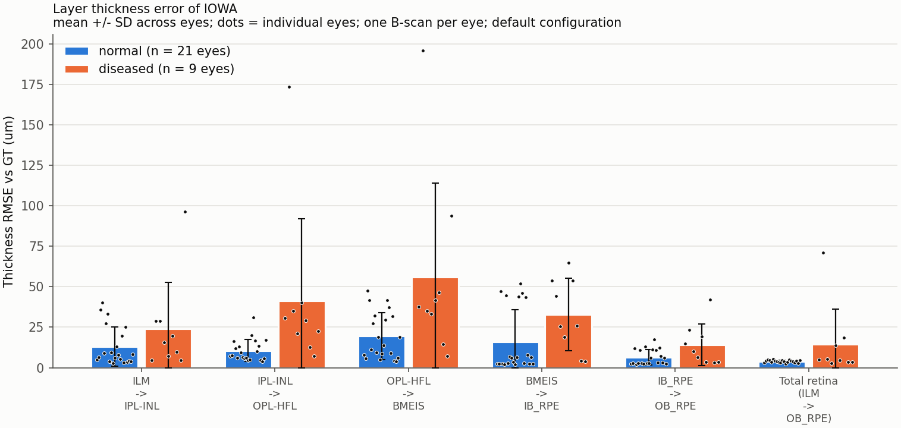
Figure 3. Thickness error (RMSE) per layer and for the total retina.
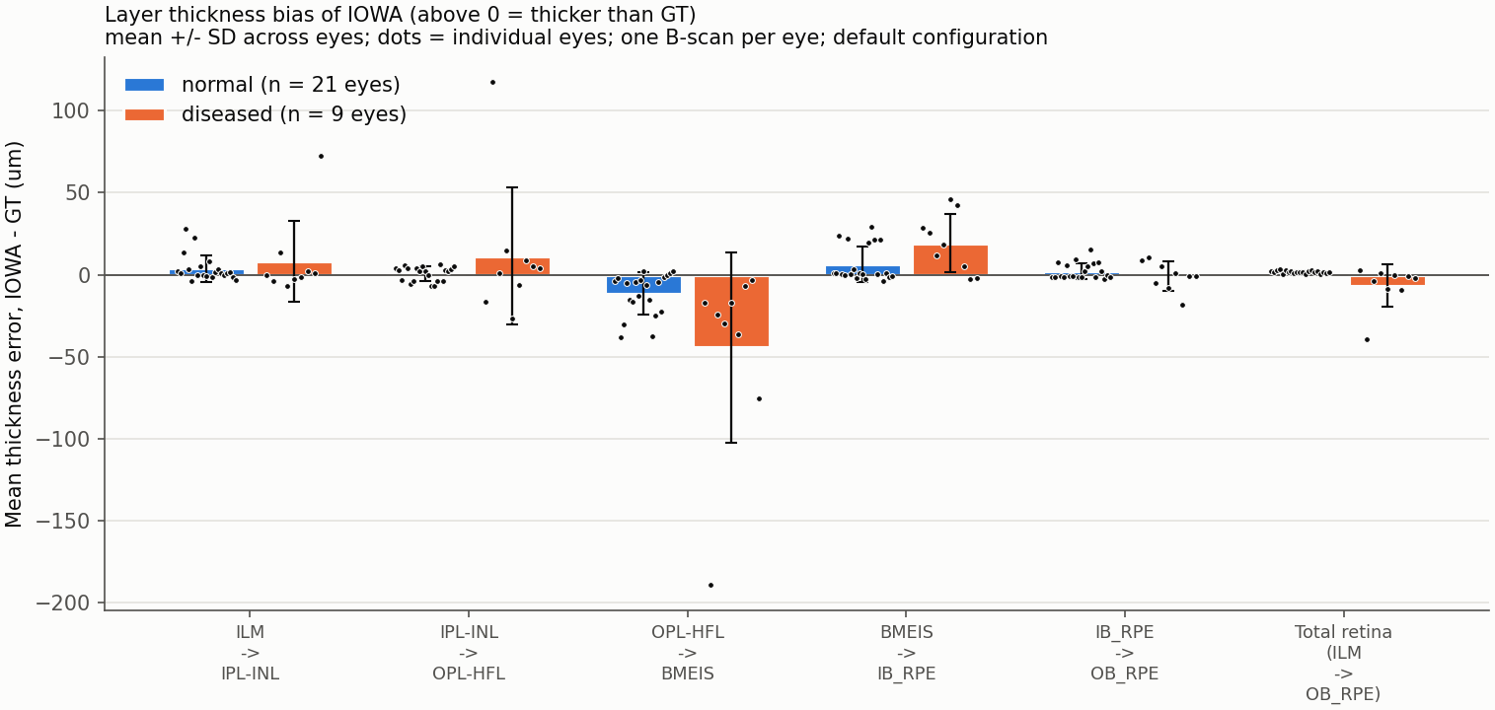
Figure 4. Mean signed thickness error. Above 0: IOWA thicker than GT. Below 0: thinner.
The full per-image thickness numbers (mean, median, SD per layer, GT and IOWA) are in tables/thickness_per_eye.csv and tables/thickness_per_bscan.csv.

3.4 Diseased-looking images: the three worst
Eye | B-scan | RMSE, all boundaries (um) | Worst boundary (RMSE, um) | Dice, whole retina
10306 | 124 | 99.6 | OPL-HFL (173.7) | 0.958
10380 | 119 | 56.5 | IPL-INL (98.6) | 0.995
10325 | 133 | 30.8 | BMEIS (62.5) | 0.984
10335 | 138 | 28.9 | BMEIS (54.3) | 0.992
10302 | 160 | 28.7 | BMEIS (62.5) | 0.989
10310 | 149 | 25.4 | OPL-HFL (44.9) | 0.991
10367 | 147 | 18.3 | IB_RPE (32.8) | 0.981
10317 | 212 | 12.5 | BMEIS (22.2) | 0.996
10373 | 194 | 5.2 | OPL-HFL (9.4) | 0.995

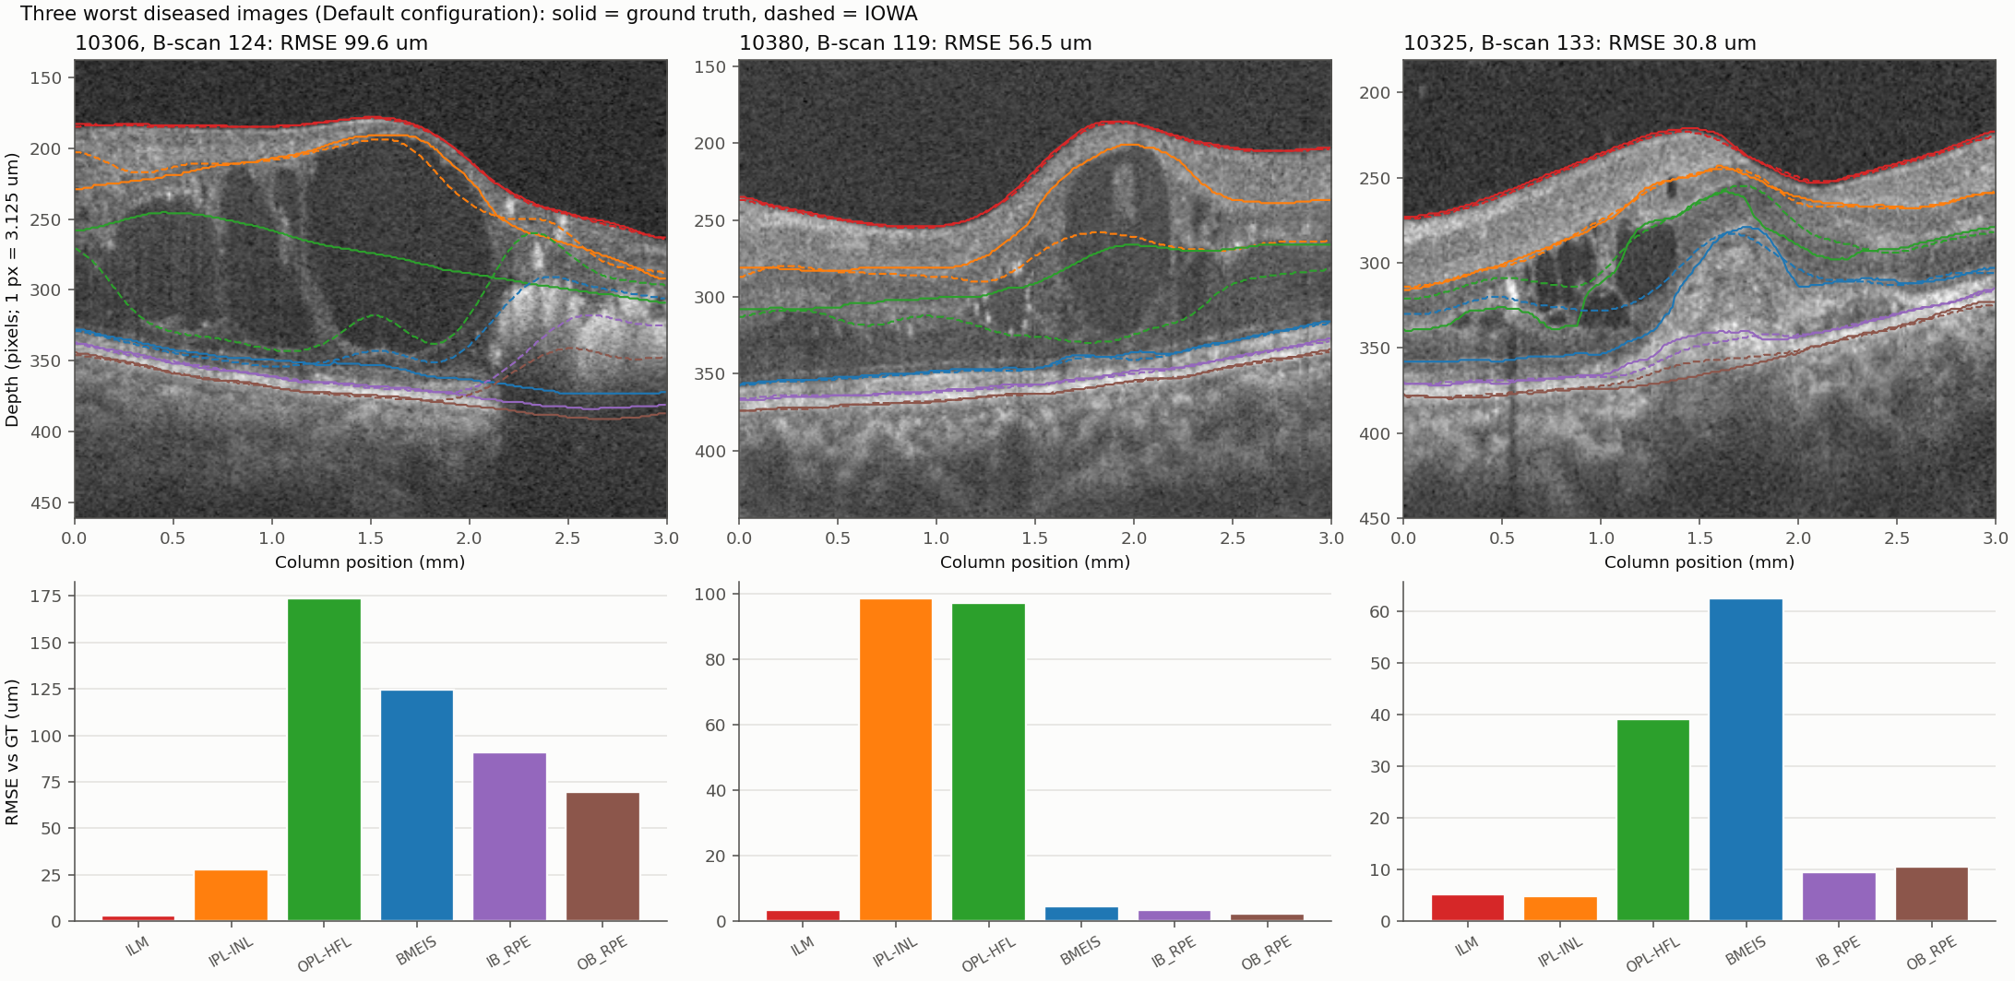
Figure 5. The three worst diseased-looking B-scans. Solid lines: GT. Dashed lines: IOWA. Bars: RMSE of each boundary.
What we see in the pictures (our reading, not a clinician's):
- Eye 10306: large dark fluid-filled cysts fill most of the retina on the left and centre. IOWA's OPL-HFL line (green, dashed) follows the cyst walls and drops down into the cyst area instead of staying along the layer, so it is far from GT. On the right, a bright patch with a shadow below it pulls IOWA's two lowest boundaries (the RPE lines) upward away from GT.
- Eye 10380: a dome-shaped swelling with a dark fluid pocket. IOWA places the IPL-INL line (orange) lower than GT inside the dome, and the OPL-HFL line is also off. The top surface and the bottom boundaries are still good.
- Eye 10325: small cysts on the left and a raised bump in the middle. IOWA's BMEIS line (blue) and OPL-HFL line (green) do not follow GT over the bump and the cysts.
- In all three, the top surface (ILM) is right. The errors begin where there are cysts or swelling, and the inner boundaries are the ones that lose their way.
- No boundaries cross or go missing in these three images (tables/t4_failure_stats.csv).

3.5 Normal-looking images also have large errors at the foveal pit
We expected small errors in normal-looking eyes. For 8 of 21 of them the overall RMSE is 10 um or more (10 um is our own rough cut-off, not a standard). Among these, the boundary with the largest error is BMEIS in 6, OPL-HFL in 1, IPL-INL in 1 of them. Total thickness is still good in these eyes (median RMSE 4.4 um); the error is in an inner boundary.
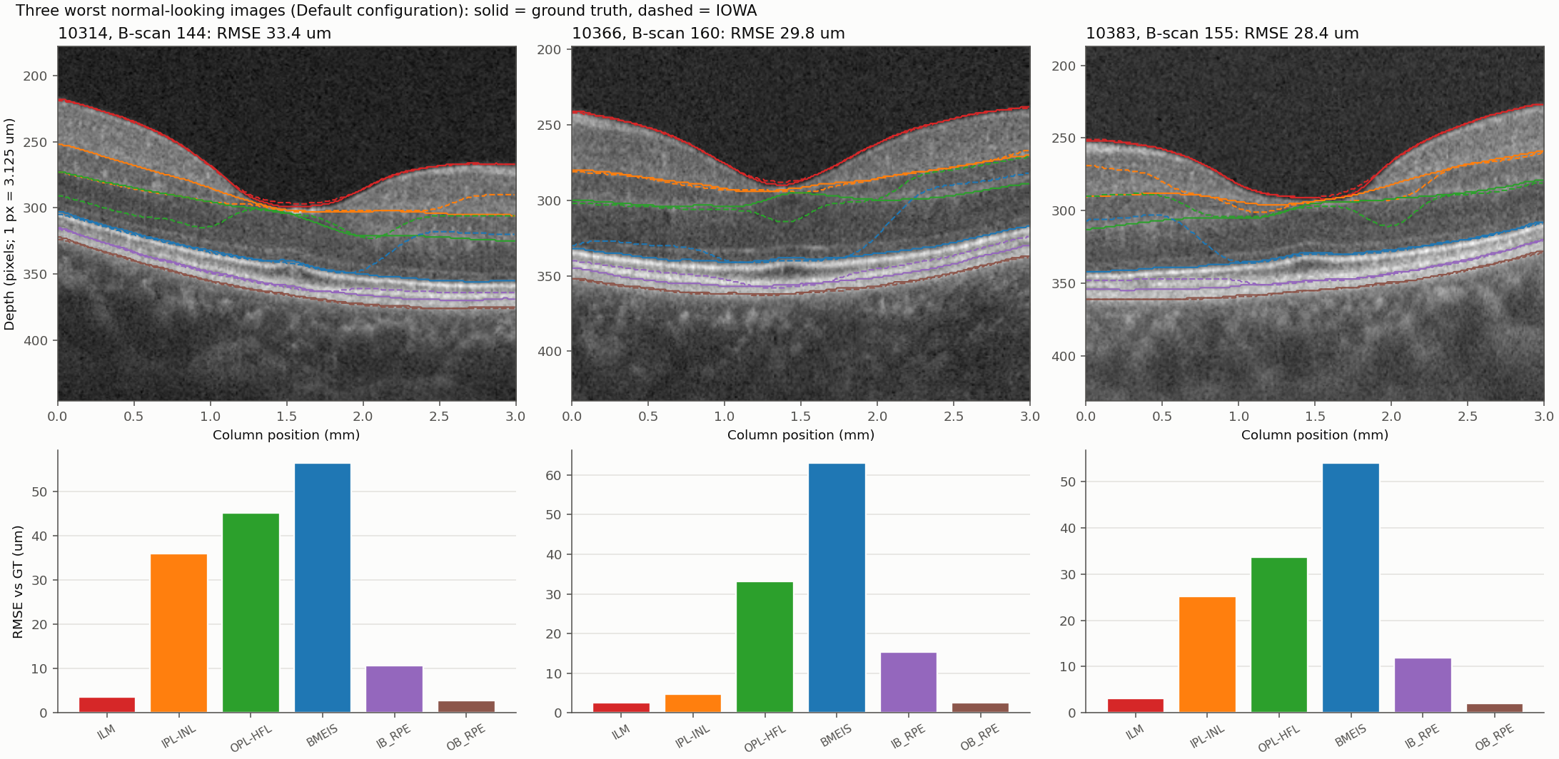
Figure 6. The three worst normal-looking B-scans (all at the foveal pit). Solid: GT. Dashed: IOWA.
What we see: at the pit the layers become very thin and merge, so the line between them is hard to place. IOWA's OPL-HFL line (green) dips below GT on one side of the pit. In some eyes IOWA's BMEIS line (blue) jumps up into the retina on one side. We checked that GT lines sit where the image suggests, and that the same code gives a median of 4.9 um on the normal-looking eyes below the cut-off, so we do not think this is a scoring mistake. We cannot say which line is anatomically right in every case.
This matters for reading the groups. Normal-looking eyes were scored at the foveal pit, a place where IOWA often struggles in this data, so their error may be higher than for a typical B-scan away from the pit. We did not score other B-scans, so we cannot say by how much.

4. Discussion
The outer boundaries and the top surface are close to GT (ILM 3.2 um and OB_RPE 2.6 um in normal-looking eyes). The inner boundaries IPL-INL, OPL-HFL and BMEIS are where the large errors are (section 3.1).
Total retinal thickness is much better than the individual boundaries: thickness RMSE 3.9 um (normal-looking) and 14.3 um (diseased-looking) (section 3.3). The whole-retina Dice value is almost perfect in both groups (0.993 and 0.987), but this number hides the errors inside the retina, so the per-layer values matter more (section 3.2).
The overall boundary error (RMSE over all six boundaries) was 13.7 +/- 10.9 um in normal-looking eyes (n = 21) and 34.0 +/- 28.5 um in diseased-looking eyes (n = 9). The spread between eyes is large, and the SD is often as large as the mean, so the difference between the groups should be read as a trend, not a proven difference. In the three worst diseased-looking images the errors begin where there are cysts or swelling, and the inner boundaries are the ones that lose their way, while the top surface is right (section 3.4).
Only 13 of 21 normal-looking and 1 of 9 diseased-looking images have an overall RMSE below 10 um. Many normal-looking foveal-pit images also show large errors. This is a finding, not an error in scoring (section 3.5). At the pit the layers become very thin and merge, so the line between them is hard to place.
Because the ground truth was started from IOWA's own output and then hand-corrected, these numbers probably flatter IOWA (section 4.1).

4.1 Limitations
- Circular ground truth. The GT boundaries were started from IOWA 3.8 output and corrected by hand. IOWA agrees with GT partly because it helped to make it. The real error against the true anatomy is probably larger than reported here.
- Few images. 30 B-scans, one per eye, out of the 30 planned. Only 9 are diseased-looking, and one B-scan cannot represent a whole eye.
- The groups are our own visual judgement, not clinical diagnoses. Mild disease may sit in the normal group.
- Different choice of B-scan per group: foveal pit (normal) and most abnormal B-scan (diseased). The groups are therefore not matched, and the normal-group error is a pit error.
- Default configuration only. The Cyst configuration was not tested, so we cannot say whether it would do better on the cystic eyes.
- One scanner and one dataset (OCTA-500, 3 mm). Results may not carry over to other devices or to the 6 mm scans.
- 21-scan volumes, not full volumes. Checked on one normal eye only.
- The software version used is labelled 5.0.0b.

5. Conclusion
On one B-scan from each of 30 eyes, IOWA's top surface and its lowest boundary agree closely with the ground truth in normal-looking eyes (ILM 3.2 um and OB_RPE 2.6 um), while the inner boundaries IPL-INL, OPL-HFL and BMEIS carry the large errors. Total retinal thickness is much better than the single boundaries (3.9 um in normal-looking and 14.3 um in diseased-looking eyes). The overall boundary error was larger in diseased-looking eyes (34.0 um) than in normal-looking eyes (13.7 um), where the errors begin at cysts and swelling. Normal-looking eyes also show large errors at the foveal pit, in 8 of 21 images. Because the ground truth began with IOWA's own output and the groups are small and visually defined, these results are a trend and not a final measure.

6. Future work
- Run the Cyst configuration on the cystic eyes and compare it with the Default configuration. A lower score against GT would not by itself show that the Cyst configuration is worse, because the GT began with IOWA's own output.
- Run IOWA on full 304-scan volumes and compare the result with the 21-scan volumes used here, which we checked on one eye only.
- Use clinical diagnosis labels instead of our visual grouping, and choose the same kind of B-scan in both groups so that the groups are matched.
- Compare IOWA with a reference that is independent of IOWA, so that the agreement is not circular.
- Find out why the inner boundaries fail. Here we described it only from the overlays of six images.
- Compare the remaining segmentation algorithms planned in the project with IOWA, and compare layer thickness between the algorithms.

7. References
The Iowa Reference Algorithms and OCTExplorer were provided by The University of Iowa Research Foundation. We acknowledge the providers' scientists: Michael D. Abramoff, Mona K. Garvin, Andreas Wahle, Kyungmoo Lee and Milan Sonka.
1. Li M, Huang K, Xu Q, Yang J, Zhang Y, Ji Z, Xie K, Yuan S, Liu Q, Chen Q. OCTA-500: A retinal dataset for optical coherence tomography angiography study. arXiv:2012.07261 (v3), 2022.
2. Abramoff MD, Garvin M, Sonka M. Retinal imaging and image analysis. IEEE Reviews in Biomedical Engineering 3:169-208, 2010. doi:10.1109/RBME.2010.2084567
3. Li K, Wu X, Chen DZ, Sonka M. Optimal surface segmentation in volumetric images - a graph-theoretic approach. IEEE Transactions on Pattern Analysis and Machine Intelligence 28:119-134, 2006. doi:10.1109/TPAMI.2006.19
4. Garvin MK, Abramoff MD, Wu X, Burns TK, Russell SR, Sonka M. Automated 3-D intraretinal layer segmentation of macular spectral-domain optical coherence tomography images. IEEE Transactions on Medical Imaging 28(9):1436-1447, 2009. doi:10.1109/TMI.2009.2016958
5. Quellec G, Lee K, Dolejsi M, Garvin MK, Abramoff MD, Sonka M. Three-dimensional analysis of retinal layer texture: identification of fluid-filled regions in SD-OCT of the macula. IEEE Transactions on Medical Imaging 29:1321-1330, 2010. doi:10.1109/TMI.2010.2047023

8. Appendix A: every scored image
Eye | Group | B-scan | RMSE all (um) | Worst boundary (um) | Dice whole retina
10302 | diseased | 160 | 28.7 | BMEIS (62.5) | 0.989
10306 | diseased | 124 | 99.6 | OPL-HFL (173.7) | 0.958
10310 | diseased | 149 | 25.4 | OPL-HFL (44.9) | 0.991
10317 | diseased | 212 | 12.5 | BMEIS (22.2) | 0.996
10325 | diseased | 133 | 30.8 | BMEIS (62.5) | 0.984
10335 | diseased | 138 | 28.9 | BMEIS (54.3) | 0.992
10367 | diseased | 147 | 18.3 | IB_RPE (32.8) | 0.981
10373 | diseased | 194 | 5.2 | OPL-HFL (9.4) | 0.995
10380 | diseased | 119 | 56.5 | IPL-INL (98.6) | 0.995
10304 | normal | 156 | 4.9 | OPL-HFL (9.3) | 0.995
10307 | normal | 157 | 4.3 | OPL-HFL (6.5) | 0.992
10314 | normal | 144 | 33.4 | BMEIS (56.6) | 0.992
10315 | normal | 152 | 24.6 | OPL-HFL (43.6) | 0.992
10320 | normal | 154 | 7.0 | OPL-HFL (12.8) | 0.993
10323 | normal | 163 | 26.7 | BMEIS (52.5) | 0.993
10330 | normal | 157 | 19.6 | IPL-INL (34.4) | 0.991
10334 | normal | 153 | 4.3 | OPL-HFL (6.6) | 0.993
10340 | normal | 155 | 9.6 | OPL-HFL (12.3) | 0.994
10343 | normal | 162 | 4.0 | OPL-HFL (6.7) | 0.993
10356 | normal | 152 | 5.0 | OPL-HFL (8.5) | 0.993
10357 | normal | 158 | 8.7 | OPL-HFL (15.1) | 0.992
10363 | normal | 154 | 23.8 | BMEIS (51.0) | 0.996
10366 | normal | 160 | 29.8 | BMEIS (63.1) | 0.994
10372 | normal | 143 | 27.6 | BMEIS (54.3) | 0.992
10377 | normal | 152 | 5.4 | OPL-HFL (11.1) | 0.993
10383 | normal | 155 | 28.4 | BMEIS (54.0) | 0.995
10395 | normal | 154 | 4.5 | IB_RPE (6.7) | 0.992
10396 | normal | 153 | 3.6 | OPL-HFL (4.9) | 0.994
10398 | normal | 148 | 4.4 | OPL-HFL (6.3) | 0.994
10399 | normal | 156 | 8.9 | OPL-HFL (18.7) | 0.993

9. Appendix B: code
The code is in the repository https://github.com/Priyanshu-kapoor/oct-iowa-validation. The folders named in this report (scripts/, tables/, figures/, outlines/, maps/) are folders of that repository. The table lists the scripts in scripts/.
Script | What it does | Input | Output
gate_check.py | reproduces 3.84 um for 10301 (B-scans 120-180) from the existing XML. Result 3.8439 um | existing IOWA result and GT of eye 10301, B-scans 120-180 | tables/gate_10301.csv
screen_abnormal.py | GT-only abnormality screen of all 98 eyes -> tables/abnormal_screening.csv | GT layers of all usable eyes | tables/abnormal_screening.csv
make_selection.py | the 30 eyes, chosen B-scan, volume range, run order -> tables/image_selection.csv | GT layers; eye lists chosen by visual inspection | tables/image_selection.csv
make_volumes.py | writes the 21-scan .mhd files (step3_make_mhd.py), the pilot, and the Cyst copies in mhd_cyst/<eye>/ | OCT B-scans; tables/image_selection.csv | 21-scan .mhd/.raw volumes in mhd/ and mhd_cyst/<eye>/
make_checklist.py | writes RUN_CHECKLIST.md (35 runs, batches of 10) | tables/image_selection.csv; result files | RUN_CHECKLIST.md
watch_and_score.py | watches mhd/ and mhd_cyst/, scores each new result (chosen B-scan only), saves tables and run_timing.csv, prints "eye X done"; --status = progress and time estimate | IOWA result XML files in mhd/ and mhd_cyst/; GT | tables/scores_per_bscan.csv, scores_per_eye.csv, thickness_*.csv, run_timing.csv
score_runs.py, t1_thickness.py | same scoring / thickness tables without watching | score_runs.py: IOWA result XML files; GT; t1_thickness.py: IOWA result XML files; GT | score_runs.py: tables/scores_per_bscan.csv, tables/scores_per_eye.csv; t1_thickness.py: tables/thickness_per_bscan.csv, tables/thickness_per_eye.csv
t2_outlines.py | outline-only PNG (GT and IOWA, 304x640, white), .npy, .csv per image -> outlines/ | IOWA result XML files; GT | outlines/<eye>_<B-scan>/ (PNG, .npy, .csv)
t3_maps.py | en-face maps + 3D surfaces from VOLUMES (not single images); --stitch joins overlapping chunks -> maps/ | IOWA result XML files of volumes or chunks; GT | maps/<eye>_<range>/ (PNG, .npy); tables/map_coverage.csv
t4_diseased.py | diseased images: per-layer error, 3 worst overlays, failure stats; Cyst vs Default per layer | tables/scores_per_eye.csv, tables/thickness_per_eye.csv; IOWA result XML files | tables/t4_*.csv; figures/t4_worst3_overlay*.png; Cyst-vs-Default figures when Cyst runs exist
t5_bars.py | bar graphs normal vs diseased with error bars (SD across eyes, every eye as a dot) -> figures/ | tables/scores_per_eye.csv, tables/thickness_per_eye.csv | figures/bars_*.png; tables/bars_*.csv
t6_runtime.py | run time per eye (Pre->Final file times, whole cycle), normal vs diseased bars, time vs error correlation -> tables/runtime_*.csv, figures/bars_runtime.png, figures/scatter_runtime_vs_error.png | tables/run_timing.csv, tables/scores_per_eye.csv | tables/runtime_*.csv; figures/bars_runtime.png, figures/scatter_runtime_vs_error.png
build_report.py | writes report/IOWA_vs_GT_report.docx from the saved tables and figures | tables/, figures/, maps/, outlines/ | report/IOWA_vs_GT_report.docx
build_report_part1.py | writes report/IOWA_vs_GT_report_Part1.docx (Part 1: boundary error, layer overlap, thickness, worst images) | tables/, figures/ | report/IOWA_vs_GT_report_Part1.docx
edge_effect.py, compare_pilot.py | evidence for "is 21 scans enough?" (before / after the pilot run) | edge_effect.py: tables/scores_per_bscan.csv; compare_pilot.py: 21-scan and 61-scan IOWA results of eye 10301; GT | edge_effect.py: tables/edge_effect_10301.csv; compare_pilot.py: tables/pilot_21_vs_61.csv
w2common.py, w2tables.py | Shared code: loading GT and IOWA surfaces, layer names, eye groups, run discovery; scores and layer thickness for one run. | GT layers; IOWA result XML files | (used by the other scripts)

